CAPRI Training Session 2014

Thünen Institute Braunschweig 9th – 11th Sept. 2014

Aims of the Training Session
- Learning to analyse how different agriculture related policies impact on markets, farm decisions and income, and the environment
- Improving knowledge about agricultural economics and quantitative modelling of agriculture
- Learning how to work with result sets from the CAPRI model and its Graphical User Interface (GUI)

Layout of the Training Session
The Training Session will use existing result sets from scenario analysis based on CAPRI. Participants will not run the model itself, a GAMS installation of GAMS is not necessary. The participants will work in small groups (3-6), focusing on specific aspects such as farm program changes, impacts on markets or trade or environmental impacts, supervised by a trainer. The current Training Session is organized under the umbrella of the TRUSTEE project (http://www.trustee-project.eu). The annual TRUSTEE meeting 2014 is scheduled the day before at the 8th of September 2014 in Braunschweig at the same venue.

Laptop needed
Participants should bring along a Laptop with about 1.5 Gigabyte of free space and should have access to an administrator account if TortoiseSVN a newer Java Run Time Engine (32bit) are not yet installed.

Costs
Participants have to cover travel and accommodation. There is no fee for the training itself, the excursion and the hotel shuttle bus.

Venue
Thünen Institute, Bundesallee 50, 38116 Braunschweig, Germany

Contact
lilli.schroeder@ti.bund.de, alexander.gocht@ti.bund.de

Trainer
Alexander Gocht, Wolfgang Britz, Heinz Peter Witzke, Torbjörn Jansson, Mihaly Himics, Maria Blanco, Franz Weiss, James Breen, Maria Espinosa, Pavel Ciaian

Useful training material

Preliminary Agenda

Tuesday 9th
Shuttle bus from the hotels (Best Western 8.15; CVJM 8.30) to venue
9.15 Start
- Welcome to all participants and presentation round (9:30 - 10:00)
- Technical set-up, Installation on laptops
- The basic structure of CAPRI (for beginners) (Wolfgang)
- Introduction to the baseline (Heinz Peter)

12.30 - 13.30 Lunch Break
13.30 Scenario analysis I: Trade Liberalisation (Mihaly, Heinz Peter)
Presentation of new Modules:
- Tariff aggregation (Mihaly with contribution from the Swiss team)
- New policy layer (Heinz Peter)
- The new global Database (Mihaly)
- Foreseen Free Trade Agreement (FTA) Scenario: Switzerland-EU FTA
18.00 Shuttle bus to City, Evening event & Dinner

Wednesday 10th
Shuttle bus from the hotels (Best Western 8.15; CVJM 8.30) to venue
9.15 Start
Scenario analysis II: Baseline and long-time projection and simulation for GHG policies (Heinz Peter, Wolfgang, Franz, Maria B.)
12:30-13:00 Lunch Break
Excursion, Evening Event & Dinner
21.30 Shuttle bus to Hotels (City)

Thursday 11th
Shuttle bus from the hotels (Best Western 8.15; CVJM 8.30) to venue
9.15 Start
Scenario analysis III: CAP 2013 (Torbjörn, Alex, Pavel, Maria E.)
12.30 - 13.30 Lunch Break + Feedback Round
14:30 Finish

Accommodation

We reserved a contingent for two different hotels. You should use the provided link (deadline 14.07.2014) for booking. Select the day of arrival and the number of nights you want to stay, you then can select one of the following hotels:

CVJM Hotel
Address: Wollmarkt 9-12, 38100 Braunschweig
Phone: +49 531 244 40 0, Fax: +49 531 244 40 49
E-mail: reception@hotelamwollmarkt.de; http://www.hotelamwollmarkt.de/
(Contingent) Price per night single room 63 €

Best Western Hotel Stadtpalais
Address: Hinter Liebfrauen 1a, 38100 Braunschweig
Phone: +49 531 241024, Fax: +49 531 24 10 25
E-Mail: info@palais-braunschweig.bestwestern.de; Link: Best Western Stadtpalais
(Contingent) Price per night single room 106 €

Location of the Hotels, Main Train Station

and the Thünen Institute
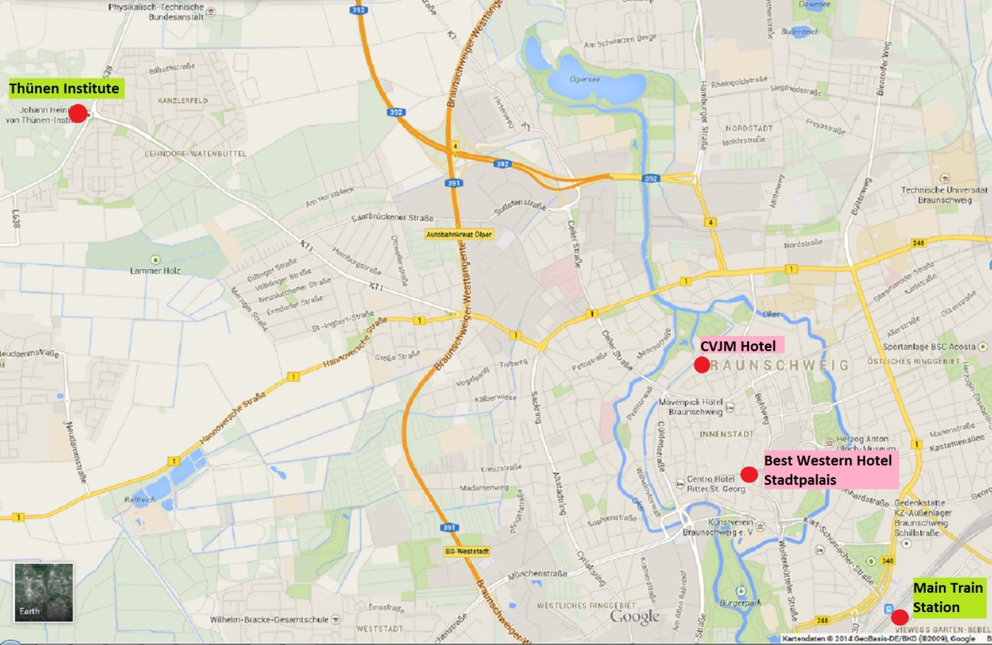

How to get from the Main Train Station to your Hotel
If you arrive in Braunschweig by train, schedules for the public buses of Braunschweig can be found here. English language () can be selected in the top-right corner.
For the Hotel CVJM enter From: "Braunschweig, Hauptbahnhof" To: "Braunschweig, Wollmarkt 9"
For Hotel Best Western Stadtpalais enter From: “Braunschweig, Hauptbahnhof“ To: "Braunschweig, Hinter Liebfrauen 1A"

How to get from your Hotel to the Thünen Institute
There will be a Bus shuttle organized by us, which picks you up at the hotels each morning (see Agenda). However, if you prefer or need to organize the transport by yourself, schedules for the public buses of Braunschweig can be found here. English language () can be selected in the top-right corner.
For the Hotel CVJM enter From: "Braunschweig, Wollmarkt 9" To: "Braunschweig, Bundesallee"
For Hotel Best Western Stadtpalais enter From: “Braunschweig, Hinter Liebfrauen 1A“ To: "Braunschweig, Bundesallee"
Note: The walk from the public bus station “Bundesallee” to the venue of the Training Session (Thünen FORUM) is long. Please let us know if you need a lift and we will pick you up each morning at the main entrance.

How to get directly to Thünen Institute Braunschweig

The headquarters of the Johann Heinrich von Thünen Institute (Thünen Institute) are located on the western limits of the city of Braunschweig (Bundesallee 50, Telephone: +49 531 - 596 0). For the Position on Google Maps please see here.

Travelling by car
Braunschweig is accessible from both the German Autobahn A2 Berlin-Dortmund (East-West) and the A39 Braunschweig-Salzgitter (North-South). Coming from Dortmund (A2): Exit the Autobahn at Braunschweig-Watenbüttel heading towards Braunschweig. Continue on the B214 to Watenbüttel, make a right at the second light, and follow the road for about 2 km, then you will find the entrance gate on the right. Coming from Berlin (A2): Exit the Autobahn at Braunschweig Nord onto the A391 heading toward Kassel. Exit the A391 at Braunschweig-Lehndorf, turn right and follow the street for about 3 km. Then you will see the entrance gate straight ahead. Coming from Kassel (A7) and Salzgitter (A39): Exit the Autobahn from Kassel at the Dreieck Salzgitter onto the A39 towards Berlin/Braunschweig. At the Dreieck Braunschweig-Südwest exit to the A391 to the Braunschweig-Lehndorf Exit, travel toward Lehndorf. After about 3 km you will see the entrance gate straight ahead.
• A travel guide with map of Braunschweig as PDF for download here
• A map of the Thünen Institute campus as PDF for download Thünen Institute Braunschweig

Travelling by train
Travel to the Braunschweig Hauptbahnhof (main train station). Travel Information for the German Railroad is available here. The Convention Bureau Braunschweig and Deutsche Bahn offer you a special price of 99 € (from every train station in Germany, including return), please see the instructions in the pdf-document “2014 DB Ticket English” attached. Regularly, the Deutsche Bahn offer you Continue your trip from the main train station with a taxi or public transportation (public buses require about 30 minutes). The bus lines M11 towards "Lamme" and the 461 towards the "PTB" run regularly from Braunschweig Hauptbahnhof. Exit the bus at the Bundesallee" stop. The bus stop is located directly at the entrance to the Thünen Institute. Since the Thünen Institute headquarters are very large, either plan for a long walk or arrange for your host to pick you up a the main entrance. A walk from the main entrance to Forum, the main location for events, requires about 15 minutes. Schedules for the public buses of Braunschweig can be found here.

Travelling by plane
Hannover Airport, transfer to main train station and then continue by train (hourly ICE and IC connections to Braunschweig) or use the Shuttle Airport-Service: Hannover-Braunschweig. Berlin Tegel or Berlin Schönefeld, transfer to main train station and then continue by train (hourly ICE connections to Braunschweig).

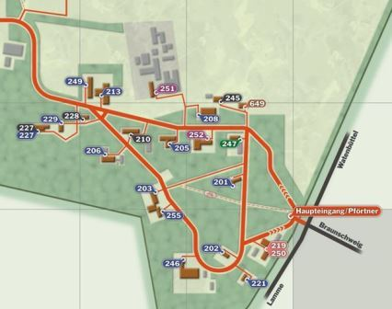
Map of the Thünen Institute campus

Forum
Bus stop
“Bundesallee“

R E G I S T R A T I O N
Training session 9-11th September 2014

How to register for the Training Session
The Thünen Institute Team in Braunschweig hosts the 2014 CAPRI Training Session. For registration please use the form below. The limited number of places available at the session will be distributed on a first-come-first-serve basis. Please send this form to lilli.schroeder@ti.bund.de not later than 14th July 2014.
First name | Please insert here your first name | Last name | Please insert here your family name

Organisation | Please insert here the name of your affiliation
Address | Please insert here the postal address of your organisation
E-mail address | Please insert here the E-mail address

Arrival |  | date | dd/mm/yy | time | hh:mm | transport | Air/train/car/other

Departure |  | date | dd/mm/yy | time | hh:mm | transport | Air/train/car/other

I will attend the evening event Tuesday 9th | Yes | ☐ | No | ☐
I will attend the dinner Tuesday 9th | Yes | ☐ | No | ☐

I will attend the excursion Wednesday 10th | Yes | ☐ | No | ☐
I will attend the dinner Wednesday 10th | Yes | ☐ | No | ☐

Hotel |  | Which hotel have you booked? (For booking, please use the link provided)

